New Mexico Educational Assistance Foundation (NMEAF)
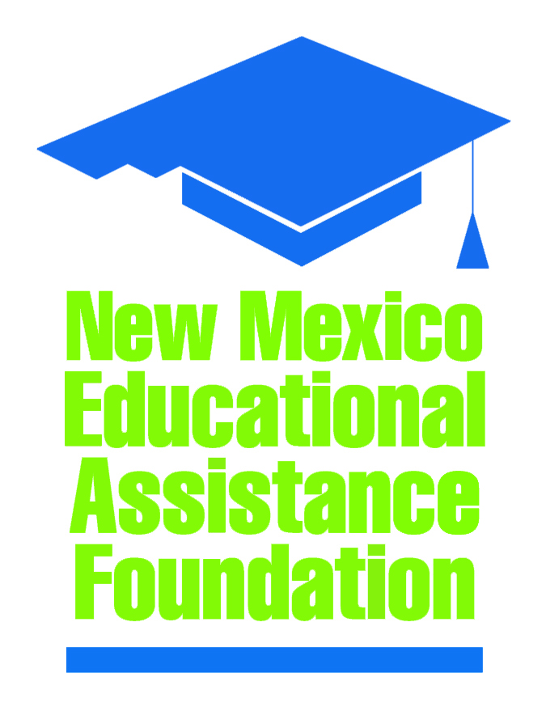
Board of Directors Budget Meeting

Location: NMEAF Conference Room/Zoom

When: June 26, 2024
10:00 AM
Agenda

I. | Call to Order – Alex Heubeck
II. | Introduction of Visitors – Brad Allpass
III. | Roll Call – Anna Smith
IV. | Approval of the Agenda* – Alex Heubeck
V. | Approval of FAFSA Student Support Strategy Expenditures FY 24 – Brad Allpass
V. | FY 2024 Budget Approval* – Tracy Rowe
VIII. | Other Matters – Brad Allpass  - Next Audit Committee Meeting: Tuesday, July 10, 2024 @ 10:00 AM  - Next Board Meeting: Monday, July 29, 2024 @ 10:00 AM
IX. | Adjournment*

